Analysis of Variance (ANOVA)
Given the raw data, we can use Excel’s Data Analysis Toolpak for both the one-way and the two-way ANOVA.

One-Way ANOVA on Data Analysis Toolpak
For One-Way ANOVA, use the “ANOVA: Single Factor” tool. The groups must be organized in columns or rows.
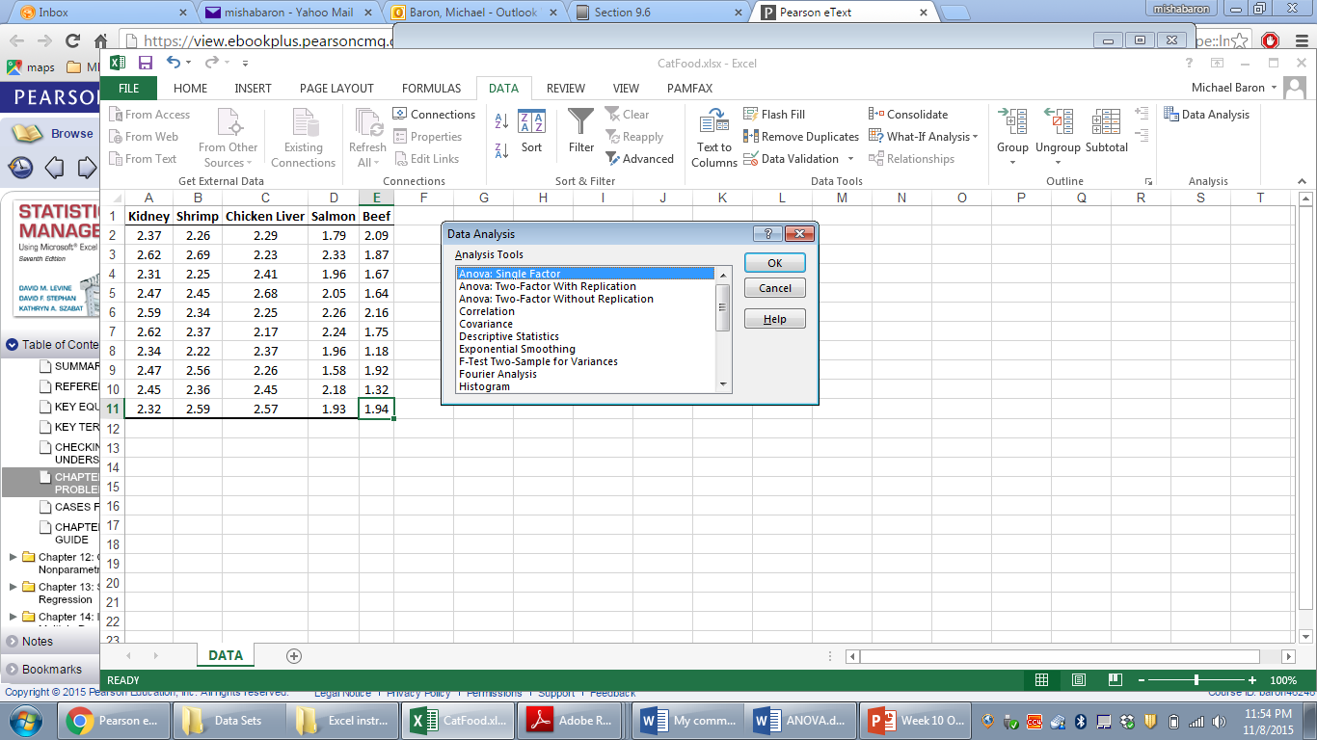

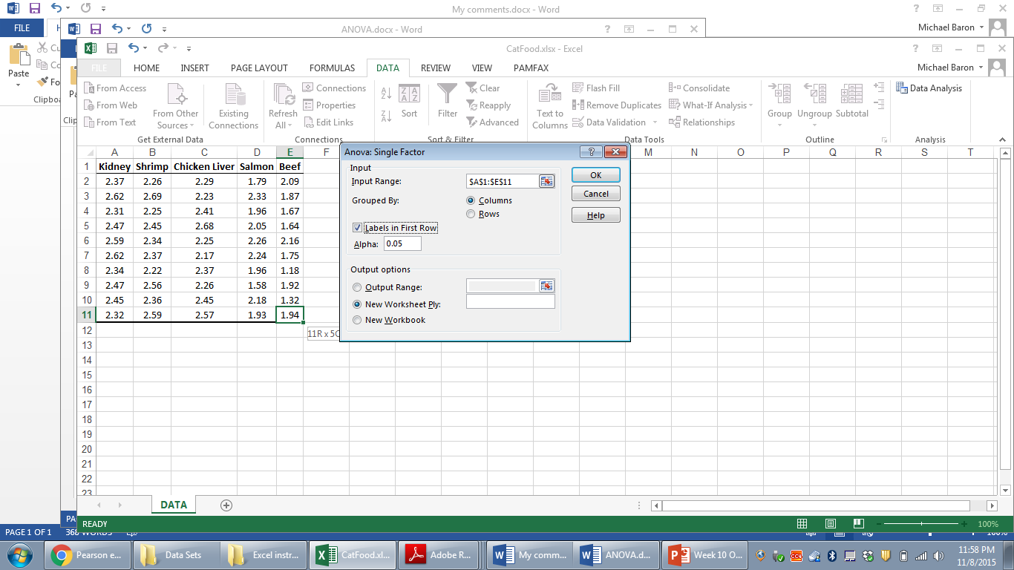
The resulting ANOVA output contains descriptive statistics (group sample means and sample variances) and the standard ANOVA table with sums of squares, degrees of freedom, mean squares, and the F-statistic with the associated p-value and rejection boundary.
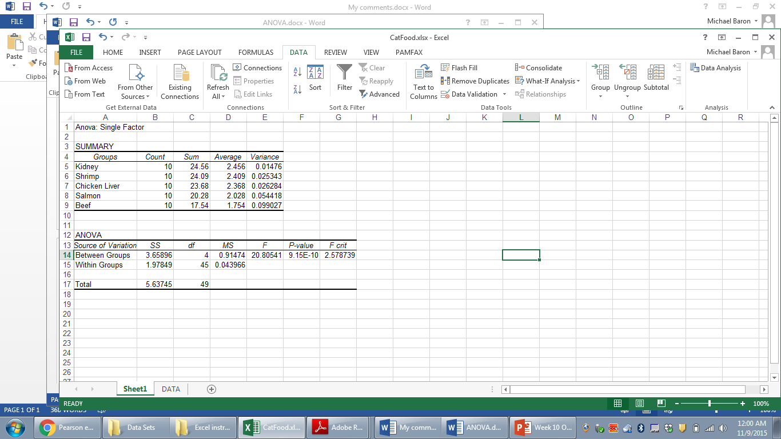

Two-way ANOVA on Data Analysis Toolpak
For the two-way ANOVA, there are two options – with and without replications. We’ll mostly have at least two replications n’ for each combination of factor levels, and therefore, we’ll use “ANOVA: two-factor with replications”.

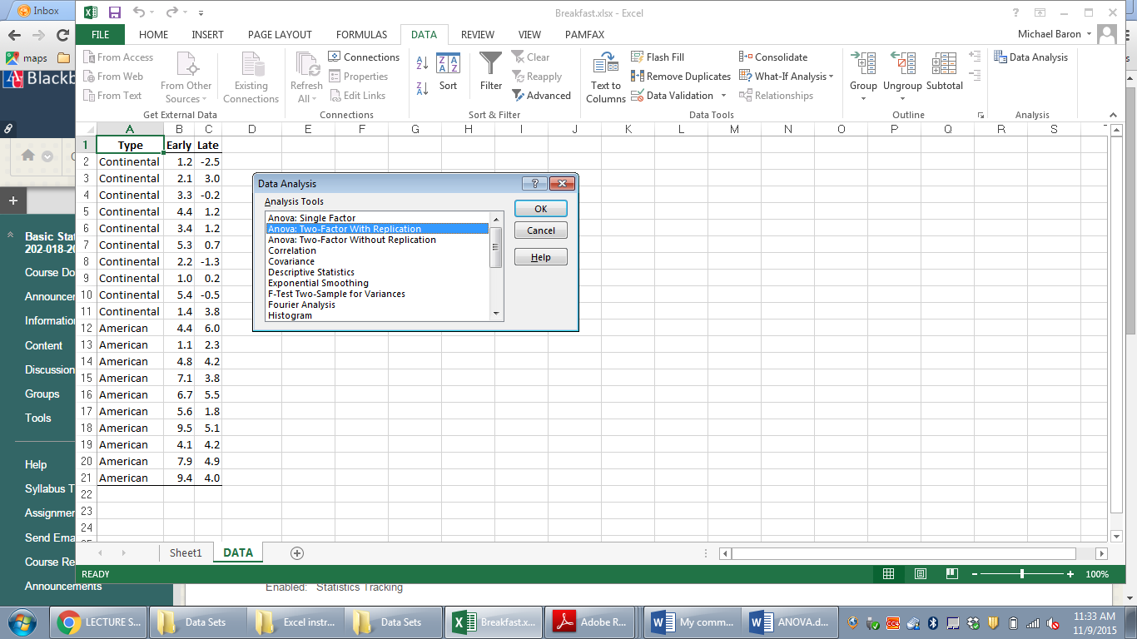

Excel will only handle balanced two-way ANOVA, where the number of replications n’ is the same for each combination. This number, n’, has to be entered as “Rows per sample”:
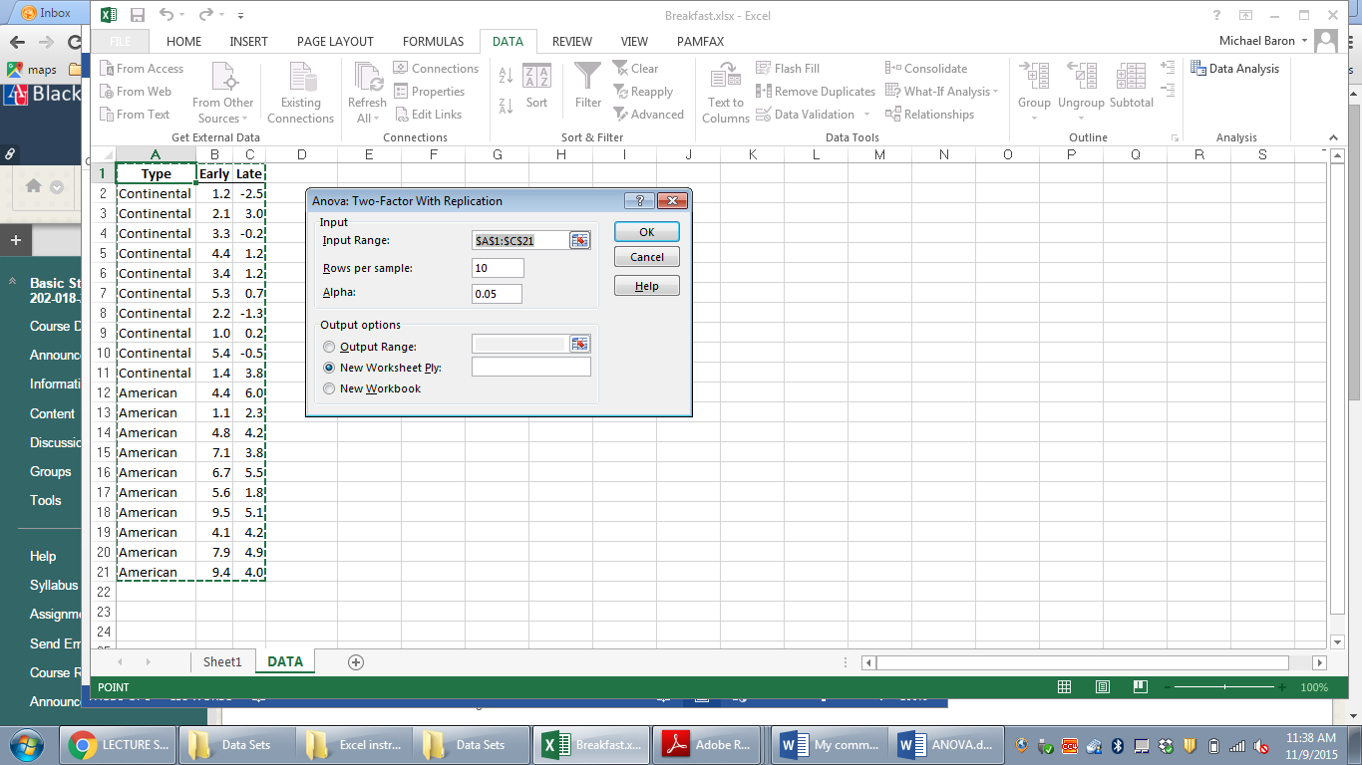

The output contains descriptive statistics for each combination of factor levels, sums of squares, degrees of freedom, and mean squares for each main factor and the interaction, the corresponding F-statistics, and their P-values.
In the current example, one factor is the time of the flight – early or late, and the other factor is the airline – American or Continental. Each factor has two levels, r=2 and c=2, and each combination of levels has n’=10 replications, for a total sample size of n=40.
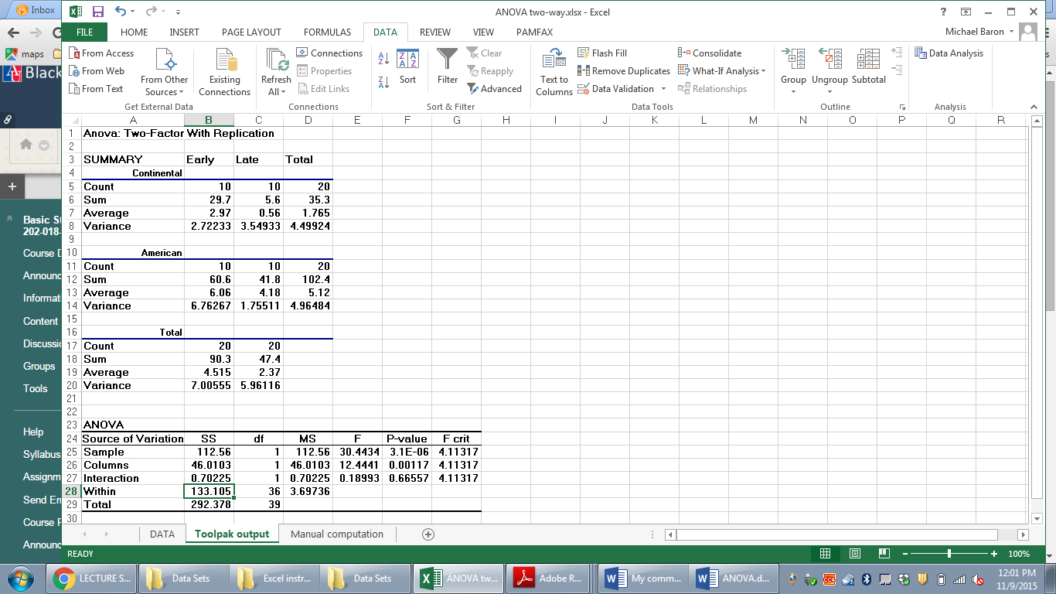
Here, the row factor (airline) is listed as “Sample”, and it is found significant with a very low p-value of 0.0000031. The column factor “Time of the flight” is listed as “Columns”, and it is found significant too, with a p-value of 0.00117. The interaction effect is not significant, with a p-value of 0.66557. Each F-statistic is obtained as a ratio of the corresponding MS and the Within MS which is also known as the Mean Squared Error (MSE).

Manual computation, formulae, and computing from descriptive statistics
All this ANOVA can also be done manually, without the Toolpak. Notice that we cannot use Toolpak if instead of the raw data, we only have the descriptive statistics – sample group means, variances, and counts.

One-way ANOVA manually
Here, I computed sample means, variances, and counts on lines 13-15. The grand mean is in H13. Then, I am using our formulae
SSA = $\sum_{j=1}^{c}{{n_{j}\left({\overline{X}}_{j}-\overset{̿}{X}\right)}^{2}}$ for the sum of squares among the groups
$SSW= \sum_{j=1}^{c}{(n_{j}-1)s_{j}^{2}}$ for the sum of squares within the groups
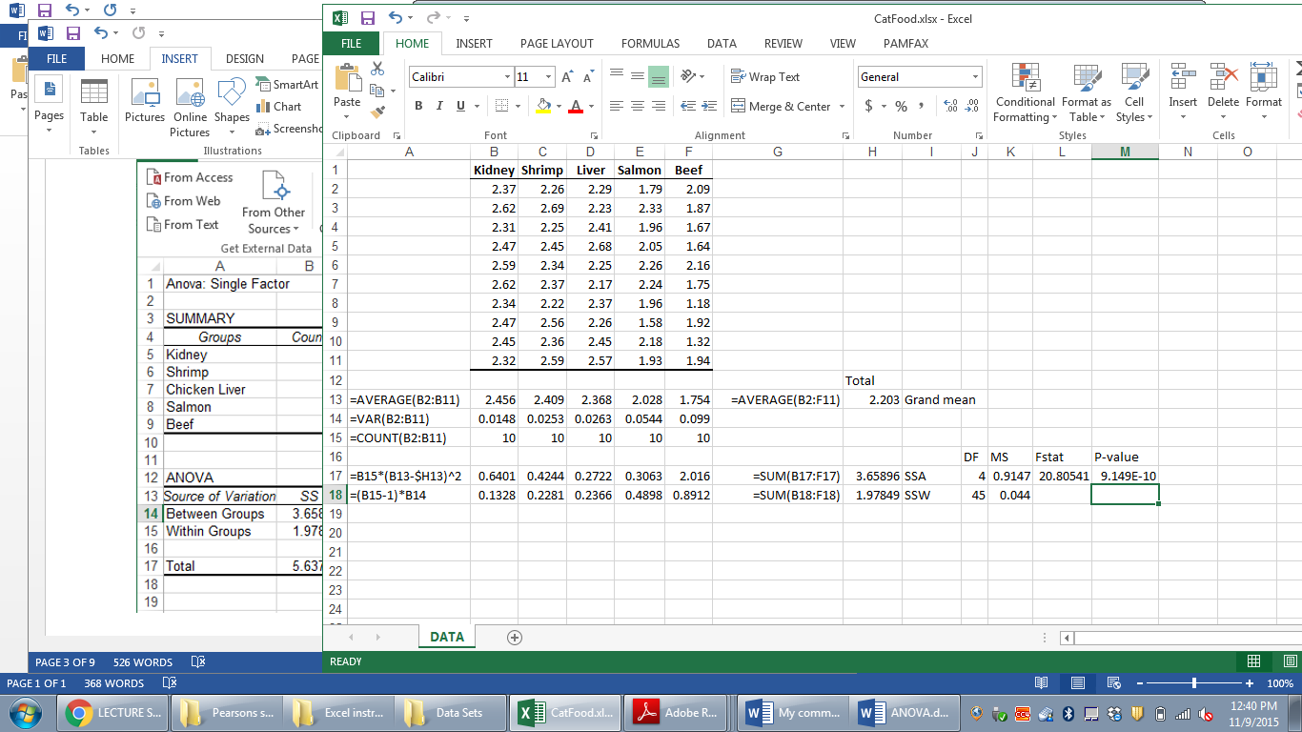
These SSA and SSW are computed in H17-18 above. Divide them by their corresponding degrees of freedom to get MSA and MSW, then compute F_{stat}=MSA/MSW, and finally, the P-value by = FDIST(L17,J17,J18).

Two-way ANOVA manually
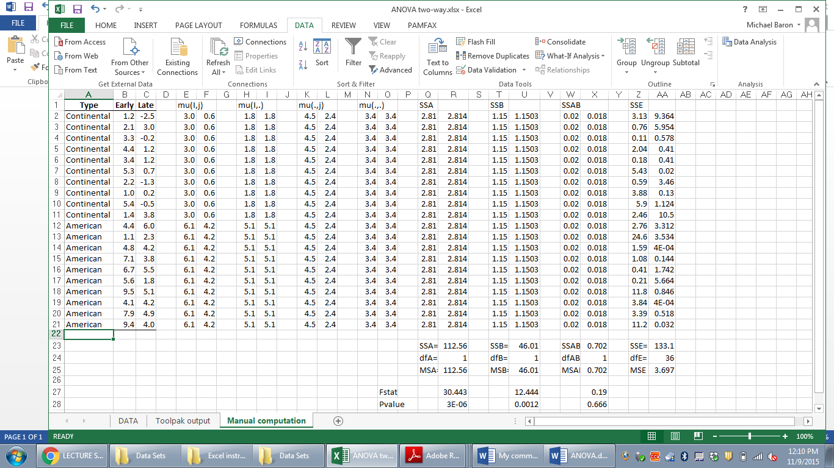
Here,
- The raw data are in columns A-C.
- Sample means , , and are computed in columns E-F, H-I, and K-L by the appropriate averaging,
=AVERAGE(B$2:B$11) for early Continental flights, =AVERAGE(B$12:B$21) for early American flights, etc.,
=AVERAGE($B$2:$C$11) for all Continental flights,
=AVERAGE($B$2:$B$21) for all early flights,
=AVERAGE($B$2:$C$21) for all the flights in the sample.
- Squared deviations are then computed in columns Q-AA. These are components of sums of squares SSA, SSB, SSAB, and SSE. They are computed as
=(H2-N2)^2 in cell Q2 for SSA
=(K2-N2)^2 in cell T2 for SSB
=(E2-H2-K2+N2)^2 in cell W2 for SSAB (SS interactions)
=(B2-E2)^2 in cell Z2 for SSE (SS error, or Within SS)
- Summing these components, we get SSA, SSB, SSAB, and SSE in line 23. For example, SSA is computed in R23 as
=SUM(Q2:R21)
- Mean Squares are computed in line 25 dividing SS by df.
- F-statistics are computed in line 27 dividing the corresponding MS by MSE. For example, to test significance of the row factor (airline), we use
=R25/$AA25
- Finally, the P-values are computed in line 28 by the command =FDIST. For example, to test significance of the airline, the P-value is computed in R28 as
=FDIST(R27,R24,$AA24)

